Shape Sailboat
Please cut out the shapes below to create a sailboat. You may choose to use different colored construction paper or to paint or color your shapes before you cut them out.
After all of the shapes are cut out it’s time to put together your sailboat!
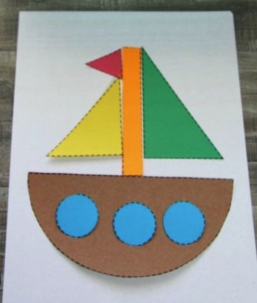
Discuss and have your child name each shape as you go.

