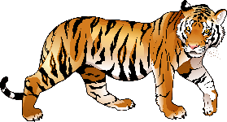
Writing Prompt -Tiger
Discuss: Tigers are carnivores and eat mostly meat (other animals).
Ask your child “If your tiger liked to eat vegetables what would his favorite vegetable be?”
Write down their answer to finish the writing prompt.
Ask your child to draw their tiger with their favorite vegetables.
Encourage them to use the appropriate colors for things like the sun, grass, sky etc.

My tiger likes to eat…

