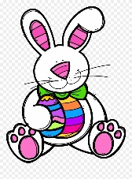
Writing Prompt – If I met the Easter bunny
Discuss the fun Easter traditions that your family shares.
Ask your child “If you met the Easter bunny what would you do? Say?
Write down their answer to finish the writing prompt.
Ask your child to draw themselves meeting the Easter bunny.
Encourage them to use the appropriate colors for things like the sun, grass, sky etc.

If I met the Easter bunny I would…

