Paper Plate Dinosaur
What you will need:
A paper plate
Toilet paper roll or paper towel roll
Paint
A googly eye
Glue
Scissors
What to do:
You may choose to have your child paint the paper plate before or after you assemble the dinosaur.
Cut the paper plate in half.
Use one side to create a dinosaur head, tail and spikes.
Have your child glue on the head, tail and spikes.
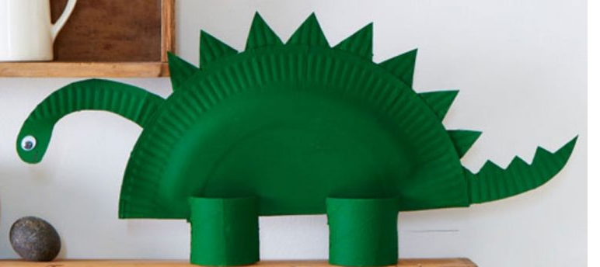
Cut a slit in the paper towel roll to create legs.

