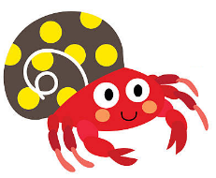
Writing Prompt -Hermit Crab
Listen to the book A House for Hermit Crab by Eric Carl
https://www.youtube.com/watch?v=C_1xqhM6_0I
Ask your child “If you were a hermit crab how would you decorate your house?”
Write down their answer to finish the writing prompt.
Ask your child to draw hermit crab in their new home.
Encourage them to use the appropriate colors for things like the sun, grass, sky etc.

If I were a hermit crab I would decorate my house with…

