Writing Prompt – Where would you hide your eggs?
Discuss the fun Easter traditions that your family shares.
Ask your child “If you were the Easter bunny where would you hide your eggs?
Write down their answer to finish the writing prompt.
Ask your child to draw the themselves hiding colorful Easter eggs.
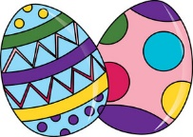
Encourage them to use the appropriate colors for things like the sun, grass, sky etc.

If I was the Easter bunny I would hide my eggs…

