Week of | April 20-24  Theme- Earth Day-Recycle
Language  Arts | Students will learn about Earth Day and how to reduce-reuse and recycle things around the house. Students will respond to the writing prompt: “I can keep the earth clean by… Students will learn recycling songs
Math | Students will use one to one correspondence to identify and count objects 1-20  Students will identify and order numbers 1-10 to create a number puzzle.
Science | Students will identify and sort objects into two categories  recycle or garbage  Students will chart how often then do things around the house  that help the planet
Motor Development | Daily outside time: Gym Day-Friday Hidden Treasure-Hide small toys or objects inside or outside. Then have your child race to find the objects- prize for finding all objects may be a special snack or more outside free play time
Religion | Students will make a new life banner! Alleluia!
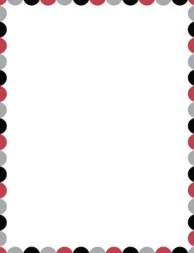
Pre-K 3 Curriculum Outline

