How to Create Your Own Climbing Rainbow

Engage your child in a conversation to make a prediction of what will happen when the paper towel is dipped into water. Then do the experiment.
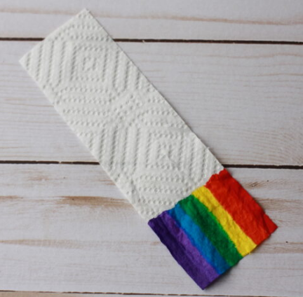
Cut a strip of paper towel approximately 2×5 inches in size. On a short edge, use markers to make a strip of blocks in the colors of the rainbow. Let the marker dry. (If the paper towel is still wet with the ink the experiment does not work as well!)

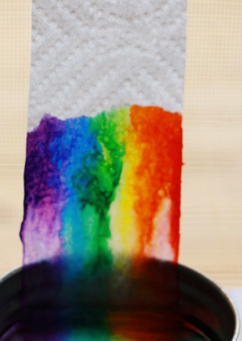
The next step can be done two different ways. You can tape the top of the paper towel to a vertical surface and put only one end in the dish.

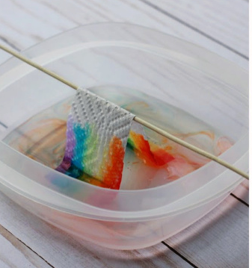
You can also create an arch using a small wooden dowel or pencil. Rest it lengthwise across an empty sandwich sized plastic container. Drape the paper towel strip across the dowel with the colored edges just touching the bottom of the container. This way requires both short ends to have colored edges.

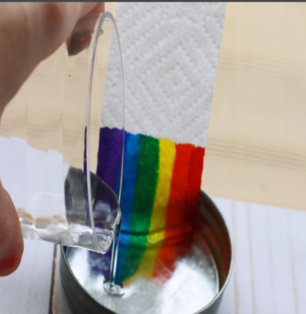
Gently pour water into the bottom of the container and watch what happens!

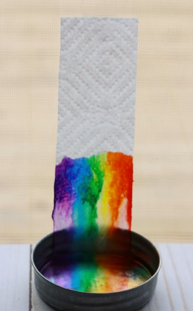

As the paper towel absorbs the water, the colors will travel up
the paper towel. Beautiful rainbow!

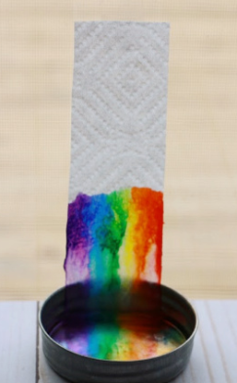
After the experiment is complete talk about their first prediction.

