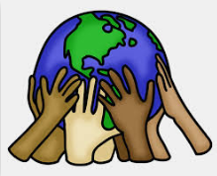
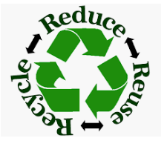
How to keep the Earth clean…

Shea- pick up garbage
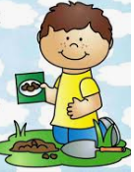
Ariah- pick up the garbage
Donny- I said I was the Earth
Meadow- recycle
Riley- pick up the cans and put them in the trash
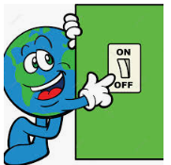
Rebekah- I pick up the trash and put it in the green box
Nailah- planted flowers and put a banana in the compost
Matthew- pick up the trash
Mackenzie- recycle
Yeva- turn off the light off in the bathroom
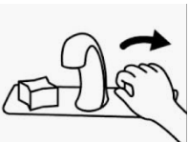
Alice- I can turn the water off all by my own self and I can brush my teeth by myself
Julianne- picking up the trash
Rosa- reuse my sister’s dress

