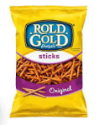
Building a Structure with marshmallows and pretzels

The link below will describe how to make various shapes using marshmallows and pretzel sticks.
Encourage your child to use the correct names such as a triangle, square, rectangle. Point out a triangle=3 sides, a rectangle has 2 long and 2 short sides, a square has 4 sides that are all the same or equal.
Be creative: there may be other objects around your house that you can create shapes with. Just have fun!
https://www.youtube.com/watch?v=8OA3IhsYYZ0

