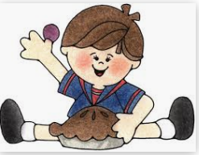
What did you pull out of your pie?

Nailah- pineapple
Donny- blueberry
Shea- an apple
Annabelle- chocolate
Rebekah- blueberries
Riley- apple
Ariah- blueberry
Gabriel- banana
Mackenzie- strawberry
Matthew-a seed
Meadow- apples
Mary Kate- lemons
Julianne- strawberry
Alice- cherries
Rosa- strawberries

