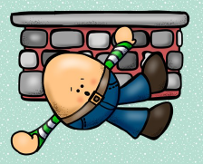
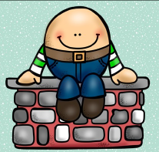
How would I fix Humpty Dumpty?

Alice- ask mommy to get him back on the wall
Mary Kate- glue him
Ariah- put a band aid
Rebekah- put a band aid and glue his pieces
Riley- tape and band aids
Donny-band aids
Matthew- super band aids
Julianne- a bandage
Mackenzie- putting band aids all over him
Gabriel- glue him back together
Yeva- glue him back together
Annabelle- tape the pieces
Rosa- get some band aids and take him to the doctor
Nailah- put a bandage on Humpty Dumpty

