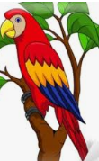
If I were a parrot I would eat…

Matthew-he flies around and eats squirrels
Alice- berries
Donny- pepperoni! I would eat pepperoni Mrs. Albert.
Mackenzie- watermelon
Annabelle- seeds
Ariah- I would eat sunflower seeds.
Rebekah- I could eat apples & blueberries and apple sauce.
Julianne- I will eat chocolate grapes and worms.
Riley- I would eat an apple, a lemon a blueberry and a rainbow flower.
Gabriel- I would eat grass.
Rosa- worms and nuts
Nailah- seeds
Meadow- leaves and flowers

