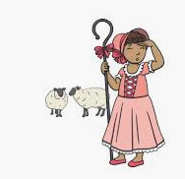
Where did Little Bo Peep find her sheep?

Mackenzie- They hid in the bushes.
Shea- Little Bo’s sheep are in my birthday cake.
Donny- in the meadow
Julianne- My sheep just hide in the tree.
Rebekah- My sheep were under the blanket on my bed.
Matthew- mine in the bush
Ariah- on the bush hiding
Riley- My sheep are in the bush.
Yeva- in the trees in the forest
Nailah- in the mountains
Rosa- My sheep is going in the farm.
Meadow- behind the door
Mary Kate- on a picnic
Gabriel- in the horse’s field
Annabelle- in the garden

