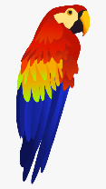
Writing Prompt – Parrots
Discuss Parrots: Parrots are omnivores, which mean that they can eat both meat and vegetation. Most parrots eat a diet that contains nuts, flowers, fruit, buds, seeds and insects. Seeds are their favorite food. They have strong jaws that allow them to snap open nutshells to get to the seed that's inside.
Ask your child “If you were a parrot what fruit or bug would you eat?”
Encourage your child to answer in a full sentence.
Write down their answer to finish the writing prompt.
Ask your child to draw themselves as a parrot eating their chosen food.
Encourage them to use the appropriate colors for things like the sun, grass, sky etc.

If I were a parrot I would eat…

